WWW.VUTUBE.EDU.PK

FINALTERM EXAMINATION
Spring 2010
PHY301- Circuit Theory
Time: 90 min
Marks: 60

Question No: 1 ( Marks: 1 ) - Please choose one
If we connect 3 capacitors in parallel, the combined effect of all these capacitors will be

► equal to the sum of individual capacitances

► sum of reciprocals of individual capacitors

► zero

► product of all

Question No: 2 ( Marks: 1 ) - Please choose one
In an N- type semicondutor material , the majority carrier are

► holes

► electrons

► ions

► protons

Question No: 3 ( Marks: 1 ) - Please choose one

Semiconductor element in pure form is called

► extrinsic

► P type

► intrinsic

► N type

Question No: 4 ( Marks: 1 ) - Please choose one
An element with 6 protons and 6 neutrons has atomic no. value

► 6

► 12

► 18

► 8

Question No: 5 ( Marks: 1 ) - Please choose one
Isotopes of an element have

► Different mass number but same atomic number

► Different atomic number but same mass number

► Same atomic and mass number

► Same no. of neutron

Question No: 6 ( Marks: 1 ) - Please choose one

Which of the following is true about the electrical circuit in your flashlight?

► The battery supplies the charge (electrons) which move through the wires.

► The battery supplies the charge (protons) which move through the wires.

► The battery supplies energy which raises charge from low to high voltage.

► Battery gets energy from circuit.

Question No: 7 ( Marks: 1 ) - Please choose one
If we connect 3 capacitors in series, the combined effect of all these capacitors will be

► equal to the sum of individual capacitors

► the sum of reciprocals of individual capacitors

► zero

► product of all

Question No: 8 ( Marks: 1 ) - Please choose one

which of following relation is true for turn ratio and voltage ratio of transformer

► N2/N1=V1/V2V1

► N2/N1=V1/V2

► N1/N2=V1V2/V2

► N2/N1=V2/V1

Question No: 9 ( Marks: 1 ) - Please choose one

Leakage current of semiconductor diode is caused by

► chemical energy

► heat energy

► barrier voltage

► doping impurity

Question No: 10 ( Marks: 1 ) - Please choose one
Rectification is the process of

► converting DC into AC

► increasing output waveform

► converting AC into DC

► converting diode into capacitor

Question No: 11 ( Marks: 1 ) - Please choose one

which rectifier is used to get either positive or negative part of input at output

► half wave rectifier

► full wave rectifier

► bridge rectifier

► negative half wave rectifier

Question No: 12 ( Marks: 1 ) - Please choose one

The reference/common point among all the nodes without insertion of any component between them is called

► node

► ground

► loop

► mesh

Question No: 13 ( Marks: 1 ) - Please choose one

In a Norton's theorem ,norton's resistance Inor is calculated

► at open terminals of the open circuit

► by short circuiting the open terminal of the circuit

► across the load

► any where

Question No: 14 ( Marks: 1 ) - Please choose one

In a thevenin's theorem , the condition to find Vth is

► to add more load resistance

► to remove load resistance

► to convert load into short circuit

► open circuit the current source

Question No: 15 ( Marks: 1 ) - Please choose one
Using superposition theorem, for a circuit containing independent sources, any remaining voltage source is

► remain same

► made zero by replacing them by open circuit

► made zero by replacing them by capacitor

► made zero by replacing them by short circuit

Question No: 16 ( Marks: 1 ) - Please choose one

In Norton, s theorem , while calculating Rn

► Short circuit the current source and open circuit the voltage source

► open circuit the current source and short circuit the voltage source

► insert the load

► just open circuit current source

Question No: 17 ( Marks: 1 ) - Please choose one
The primary function of a filter is to

► Minimize ac input variations

► Suppress odd harmonics in the rectifier output

► Stabilize dc level of the output voltage

► Remove ripples from the rectified output

Question No: 18 ( Marks: 1 ) - Please choose one

The PIV of a half wave rectifier circuit with a shunt capacitor filter is

► 2V_{m}

► V_{m}

► V_{m}/2

► 3V_{m}

Question No: 19 ( Marks: 1 ) - Please choose one
The ripple factor of a bridge rectifier

► 1.21

► 0.406

► 0.812

► 1.11

Question No: 20 ( Marks: 1 ) - Please choose one

Zener breakdown occurs

► Mostly in germanium junctions

► Due to rupture of covalent bond

► In lightly doped-junctions

► Due to thermally –generated minority carriers

Question No: 21 ( Marks: 1 ) - Please choose one

The clipping level is primarily determined by

► Shape of the input waveform

► Battery voltage

► Value of the resistor

► Knee voltage of the diode

Question No: 22 ( Marks: 1 ) - Please choose one

Without a DC source a clipper acts like a

► Rectifier

► Clamper

► Demodulator

► Chopper

Question No: 23 ( Marks: 1 ) - Please choose one
Avalanche breakdown is primarily dependent on the phenomenon of

► Collision

► Doping

► Ionization

► Recombination

Question No: 24 ( Marks: 1 ) - Please choose one

Three bulbs are connected in series of a battery, what would happen if any one bulb is opened.
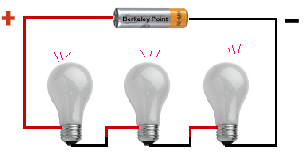

► half of current will flow

► same current will flow

► no current will flow

► 2/3 current will flow

Question No: 25 ( Marks: 1 ) - Please choose one

The base region of a p-n-p transistor is

► Very thin and heavily doped with holes

► Very thin and heavily doped with electrons

► Very thin and lightly doped with holes

► Very thin and lightly doped with electrons

Question No: 26 ( Marks: 1 ) - Please choose one
Converting 12v voltage source into current source, value of converted current source source will be
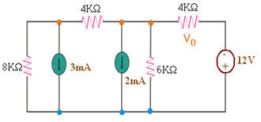

► 3mA

► 2mA

► 48mA

► 1mA

Question No: 27 ( Marks: 1 ) - Please choose one

In normal operation an n-p-n transistor connected in common-base configuration has

► The emitter at a lower potential than the base

► The collector at a lower potential than the base

► The base at a lower potential than the emitter

► The collector at a lower potential than the emitter

Question No: 28 ( Marks: 1 ) - Please choose one
The value of Ia for given circuit is

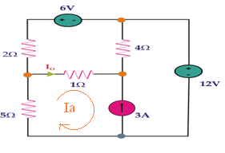

► Ia=Io

► Ia= 3A

► Ia= -3A

► Ia=6v

Question No: 29 ( Marks: 1 ) - Please choose one

Across which resistance more voltage is dropped

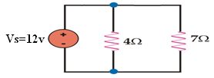

► 4Ω

► 7Ω

► same across both

► no voltage drop

Question No: 30 ( Marks: 1 ) - Please choose one
When a diode is reversed biased

► It will act as short circuit

► It will act as an open circuit

► It will act as close circuit

► maximum current flows

Question No: 31 ( Marks: 2 )

In the NPN transistor, what section is made very thin compared with the other two sections?

Question No: 32 ( Marks: 2 )
In a reverse biased PN-junction, which current carriers cause leakage current?

Question No: 33 ( Marks: 2 )

Sketch the shape of the output voltage waveform for this "clipper" circuit, assuming an ideal diode with no forward voltage drop:
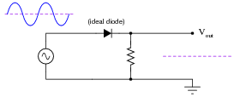

Question No: 34 ( Marks: 3 )
Find the value of IE for transistor if IB =1.5mA and IC=4mA

Question No: 35 ( Marks: 3 )

What would be the current across the load?

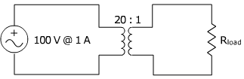

Question No: 36 ( Marks: 3 )

Keeping in mind Norton's Theorem find Norton’s Resistance R_{N}. Do not draw the circuit.write each step of calculation.

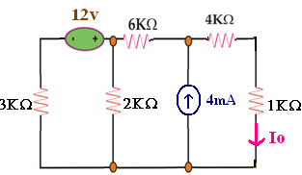

Question No: 37 ( Marks: 5 )
Predict how the operation of this clipper circuit will be affected as a result of the following faults. Consider each fault independently (i.e. one at a time, no multiple faults):
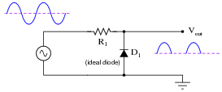
- Diode D₁ fails open:

- Diode D₁ fails shorted:

- Resistor R₁ fails open:

- Resistor R₁ fails shorted:
For each of these conditions, explain why the resulting effects will occur.

Question No: 38 ( Marks: 5 )

At what load resistance value will this voltage regulator circuit begin to lose its ability to regulate voltage? Also, determine whether the voltage regulation is lost for load resistance values greater than this threshold value, or less than this threshold value.
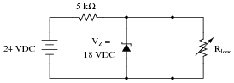

Question No: 39 ( Marks: 5 )

Find Ix by Norton's Theorem if Norton’s Resistance R_{N} is 5kΩ
and Norton’s current I_{Nor.}is 6mA , draw the Norton's equivalent circuit.
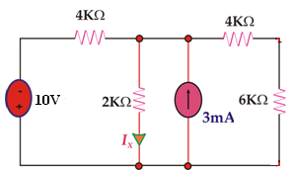
WWW.VUSR.NET

